 | PES University, Bengaluru  (Established under Karnataka Act 16 of 2013) | UE17MC503
September 2018: IN SEMESTER ASSESSMENT (ISA) MCA III SEMESTER

TEST – 1

UE17MC503 - Database Management Systems
Scheme and Solution.

Time: 1½ Hrs Answer All Questions Max Marks: 40

1. | a) | What is DBMS?
 | Sol | The DBMS is a general purpose software system that facilitates the process of defining, constructing, manipulating, and sharing databases among various users and applications. – 1 Mark | 1
 | b) | Discuss the advantages of DBMS over conventional file processing. | 5
 | Sol | Advantages of using the DBMS approach  1. Controlled Redundancy  - In the file processing approach, each user defines and implements the files needed and software applications to manipulate those files.  - Various files are likely to have different formats and programs may be written in different languages and same information may be duplicated in several files.  - Database design stores each logical data item at one place to ensure consistency and saves storage.  - But sometimes, controlled redundancy is necessary to improve the performance.  - Database should have capability to control this redundancy & maintain consistency by specifying the checks during database design.  2. Restricting Unauthorized Access  - A DBMS provides a security and authorization subsystem, which is used by DBA to create user accounts and to specify restrictions on user accounts.  - File processing system provides password mechanism and very less security which is not sufficient to enforce security policies like DBMS.  3. Providing Persistent Storage for Program Objects  - Object oriented database systems are compatible with programming languages such as C++ and Java.  - A OODBMS software automatically performs the conversion of a complex object which can be stored in OODBMS, thus an object is said to be persistent due to its survival after the termination of the program.  4. Providing Storage Structures for Efficient Query Processing  - The DBMS utilizes a variety of sophisticated techniques (view, indexes etc.) (auxiliary files) to store and retrieve the data efficiently that are utilized to improve the execution time of queries and updates.  - DBMS provides indexes and buffering for fast access of query result, the choice of index is part of physical database design and tuning.  - The query processing and optimization module is responsible for choosing an efficient query execution plan for each query submitted to the system.  5. Providing Backup & Recovery  - Data should be restored to a consistent state at the time system crash and changes being made  - If hardware or software fails in the middle of the update program, the recovery subsystem of DBMS ensures that update program is resumed at the point of failure.  6. Multiple user interfaces  - DBMS provides a variety of user interfaces for the users of varying level of technical knowledge.  - These includes query language for casual users, programming language interfaces for application programmers, forms and command codes for parametric users, menu driven interfaces and natural language interfaces for stand alone users etc  7. Representing Complex Relationships among data  - A DBMS have the capability to represent a variety of complex relationship among the data, to define new relationships as they arise, and to retrieve and update the related data easily and efficiently.  8. Enforcing Integrity Constraints  - The DBMS have certain integrity constraints that hold on data.  - These constraints are derived from the meaning of the data and of the miniworld.  - Some constraints can be specified to the DBMS at the time of defining data definitions and automatically enforced.  - Database does not allow violation of constraints at the time of updating the database.  9. Permitting Inferencing and Action Using Rules  - Deductive database systems provide capabilities for defining deduction rules for inferencing new information from the stored database facts.  - Trigger, functions, stored procedures can be associated with tables.  Any five advantages with brief explanation- 5 Marks
 | c) | What are the responsibilities of DBA? | 4
 | Sol | Database Administrator (DBA)  - This is the chief administrator, who oversees and manages the database system.  Duties include  1. Security & Authorization  - authorizing users to access the database, coordinating/monitoring its use  2. Database recovery after failures  - restoring the data, maintaining the log files  3. Database tuning  - acquiring hardware/software for upgrades, etc.
2. | a) | Explain the three-schema architecture with neat diagram. | 1+3
 | Sol | 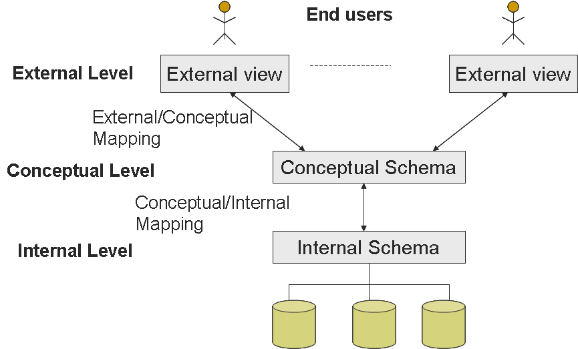- 1 Mark  The schema in DBMS can be described at three levels:  Internal Schema  - The internal schema specifies complete details of storage and access paths for the database.  - File organization on the disk should be decided e.g. hashing, indexing etc.  - The process of arriving at a good physical database schema is called physical database design.  Conceptual Schema  - The conceptual schema (or logical schema) describes the structure of the database.  - The conceptual schema hides the details of physical storage structures and concentrates on describing entities, data types, relationships, user operations, and constraints.  - A representational data model is used to describe the conceptual schema when a database is implemented.  - The process of arriving at a good conceptual database schema is called conceptual database design.  Conceptual Schema (example)  Students (sid: string, sname: string, login: string, age: integer, gpa: real)  Faculty (fid: string, fname: string, sal: real)  Courses (cid: string, cname: string, credits: integer)  External Schema  - The external schemas allow data access to be customized at the level of individual users and hide rest of the details from the users.  - Any database has exactly one conceptual schema and one physical schema but may have many external schemas in view to support different users.  - Each external schema consists of a collection of one or more number of views or tables.  The external schema design is guided by end user requirements e.g. courseinfo (cid, fname, sid)  Description of above three schemas in brief – 3 Marks
 | b) | List different steps in database design and write goal of each step. | 2+2
 | Sol | The steps in database design i.e. developing a database are  - Requirements analysis  - Conceptual Database design  - Logical Database design  - Schema refinement  - Physical Database design  - Applications and security  Requirement Analysis – To understand what data is to be stored in the database, what applications must be built on top of it etc.  Conceptual Design – The information gathered in the requirements analysis steps is used to develop a high-level description of the data to be stored in the database.  Logical Database Design- To convert the conceptual database design into a database schema in the data model of the chosen DBMS.  Schema refinement- To analyze the collection of relations in our relational database schema to identify potential problems and to refine it.  Physical Database Design – To involve building indexes on some tables and clustering some tables or it may involve a substantial redesign of the parts of database schema.  Applications and Security – To describe the role of each entity in every process that is reflected in some application task and to provide security in terms of user groups and their privileges.
3. | a) | What are Integrity constraints? Differentiate between Entity Integrity and Referential Integrity. | 1+3
 | Sol | - Conditions that must be true for any instance of the database; e.g., domain constraints.  - ICs are specified when schema is defined.  - ICs are checked when relations are modified.  - A legal instance of a relation is one that satisfies all specified ICs.  - DBMS should not allow illegal instances.  If the DBMS checks ICs, stored data is more faithful to real-world meaning.  Entity Integrity: Entity Integrity is the mechanism the system provides to maintain primary keys. The primary key serves as a unique identifier for rows in the table. Entity Integrity ensures two properties for primary keys: The primary key for a row is unique; it does not match the primary key of any other row in the table.  CREATE TABLE Enrolled  (sid CHAR(20)  cid CHAR(20),  grade CHAR(2),  PRIMARY KEY (sid,cid) )  Foreign key : Set of fields in one relation that is used to `refer’ to a tuple in another relation.  - Must correspond to primary key of the second relation. Like a `logical pointer’.  - E.g. sid is a foreign key referring to Students:  - Enrolled(sid: string, cid: string, grade: string)  If all foreign key constraints are enforced, referential integrity is achieved, i.e., no dangling references
 | b) | 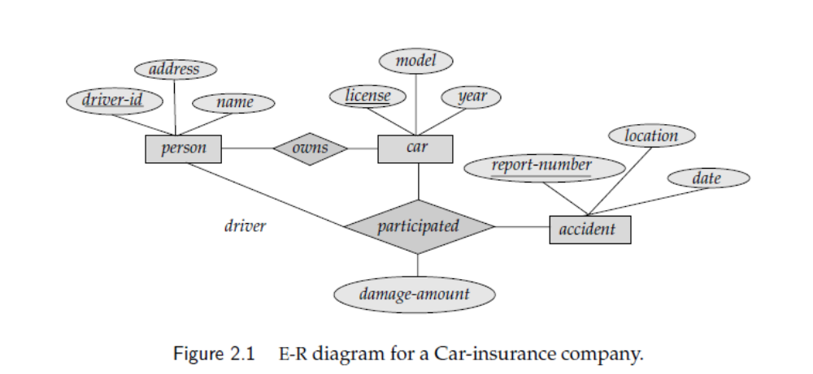  From the above ER diagram identify Entities, attributes, Relationships, Primary Keys and descriptive attributes. | 5
 | Sol | 3 Entities – Person, Car, Accident - 1 Mark  Attributes – Person (driver_id, address,name), Car(license, model, year), Accident (report_number, location, date) - 1 Mark  Relationships – Participated – 1 Mark  Primary Keys – Person(driver_id), Car(license), Accident(report_number) – 1 Mark  Descriptive attribute- Participated (damage-amount) – 1 Mark
 | c) | Order by clause is used to list the records or values from table in either ascending  or descending order.  Ex: Select * from customer order by customer_id (or) Select * from customer order by customer_id desc | 1+1
4. | a) | Consider the following database:  player (player_id, name, dob, country)  play (player_id, game_id, no_of_wickets, runscored)  one_day_game (game_id, host_country, guest_country, date)  - Draw the Conceptual Schema.  - Write the SQL statements to create the tables with primary keys, foreign keys and on delete cascade. Make the necessary assumptions for data types.  - Write the command to add a column phone-number to ‘player’ table. | 2+3
 | Sol | - Conceptual Schema  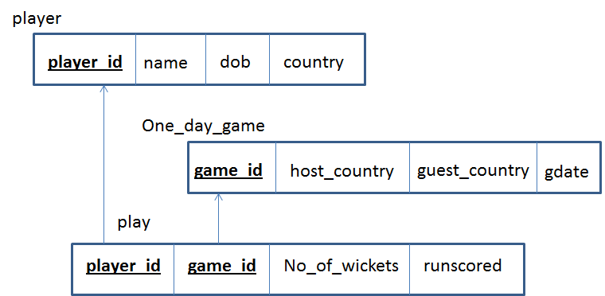  ii) Create Commands  create table player (player_id tinyint primary key, name varchar(20), dob date, country varchar(20));  create table one_day_game(game_id tinyint primary key, host_country varchar(20), guest_country varchar(20), gdate date);  create table play(player_id tinyint, game_id tinyint, no_of_wickets tinyint, runscored tinyint, primary key(player_id, game_id), foreign key(player_id) references player(player_id) on delete cascade, foreign key(game_id) references one_day_game(game_id) on delete cascade);
 | b) | Refer the database given in question 4 and answer the following queries using SQL:  - Find the birth date and country of the players whose name starts with 'R’.  - Find the details of one-day game in which ‘Dhoni’ played.  - Find the total number of games played by each player.  - Find the details of players who scored a total of more than 1000 runs. | 4
 | Sol | - Find the birth date and country of the players whose name starts with 'R’  select dob, country from player where name like ‘R%’; --- 0.5 Marks  - Find the details of one-day game in which ‘Dhoni’ played.  select * from one_day_game where game_id in  (select game_id from play where player_id in  (select player_id from player where name = ‘Dhoni’)); --- 1 Mark  - Find the total number of games played by each player.  select player_id, count(game_id) from play group by player_id; --- 1 Mark  - Find the details of players who scored a total of more than 1000 runs.  select * from player where player_id in  (select player_id from play group by player_id  having sum(runscored) > 1000); --- 1.5 Marks  - Find the details of players who have played for country ‘India’.  Select * from player where country=’india’; -- 1 Mark

************

